BTT Lawyer Application

DEFINITIONS:

IMMIGRANT: An immigrant is a person who migrates to another country.
SOLICITOR: A solicitor is a legal practitioner who traditionally deals with most of the legal matters in some jurisdictions.
He acts as a mediator between immigrant and Barrister.
BARRISTER(Member of Bar Council): He is a type of lawyer in common law jurisdictions who works at higher levels of court.
Immigration: Immigration is the process of moving people from their former country to destination country permanently.
Introduction:
The client is looking for an Android/iOS application so that the immigrant/solicitor/barrister can check the updates and process status through the app. By using this app Solicitor can reduce the communication gap between Barrister and Immigrant.
Project Description:
During the process of immigration, Immigrant need to send documents to the Solicitor who checks the documents and help the Immigrant to process their immigration.
Solicitor sends all the documents to the Barrister for further processing of the immigration.
Barrister files a petition in the Bar council on behalf of immigrant and if in case of any failure barrister requests for supporting documents from the immigrant.

Flow:
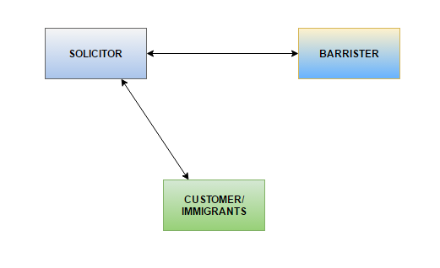
Requirements: The application should contain the below required functionality.

- Video Calling: The app should be able to make video calls so that the solicitor can record the dictation from the immigrant.
- Video Recording: The App should record the total conversation between the solicitor and the immigrant.
- Video Saving: The app should be able to save the video files in the database.
- Download: The app should provide an option to download the video files.
- Sharing Video: The app should allow Solicitor to share the video recording to Barrister.
- Notifications: All the users(Immigrant/Barrister/Solicitor) of the application should be notified whenever an update received from other user(Immigrant/Barrister/Solicitor).

Login: There are, two type of login
1. Immigrant Login
2. Barrister Login

Immigrant Functionality:
- The Immigrant should be able to Register the application using the Registration Form.
- The Immigrant should be able to Login using his credentials.
- The Immigrant should be able to upload documents required for the immigration process.
- The Immigrant should be able to receive video call from Solicitor.
Note: Immigrant can't call Solicitor and Barrister using this application.

Solicitor Functionality:
- Solicitor should be able to Login using his credentials.
- Solicitor should be able to View all the immigrants.
- Solicitor should be able to request for additional documents from immigrant
- Solicitor should be able to Register a Barrister.
- Solicitor should be able to Delete a Barrister.
- Solicitor should be able to share/download the documents and videos to Barrister.
- Solicitor should be able to call immigrant and Barrister individually.
- Solicitor should be able to invite immigrant and barrister for a conference call.
Note: Solicitor can add only one Barrister at a time.

Barrister Functionality:
- Barrister should be able to Register using the app.
- Barrister should be able to Login using his credentials.
- Barrister should be able to view/download all the documents and videos shared by Solicitor.
- Barrister should be able to request solicitor for additional documents.
- Barrister should be able to view all the details of the Immigrant shared by the Solicitor.
Note: Barrister can't view all the immigrants until solicitor shares the details with him.
Barrister can't call Solicitor and Immigrant using this application.

